https://docs.oracle.com/cd/A60725_05/html/comnls/us/ap/awtov.htm

AP发票自动生成预扣税

Checking the withholding tax setup details in payable profile setup workbench

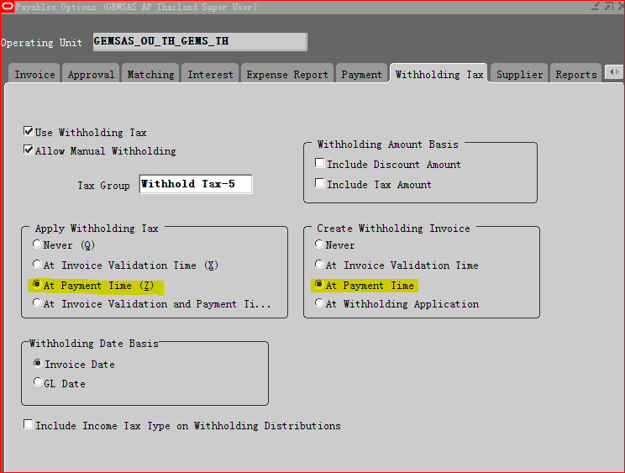

Step1:创建发票Invoice#test1004，

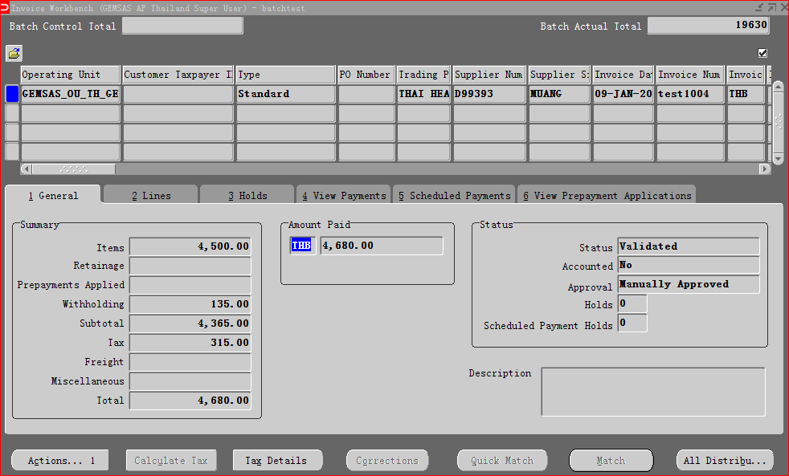

Step2:在发票Line中payment withholding tax group选项中指定withholding tax group name.

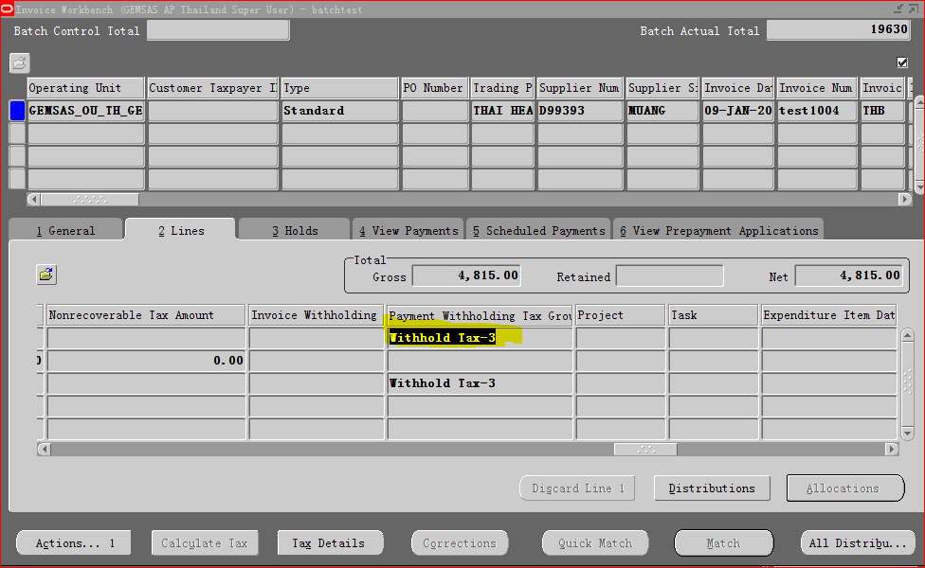

对发票进行付款

付款的时候预扣税的发票会自动生成

THB_CHK100000_200000

DETUCHBANK_THB_CHECK

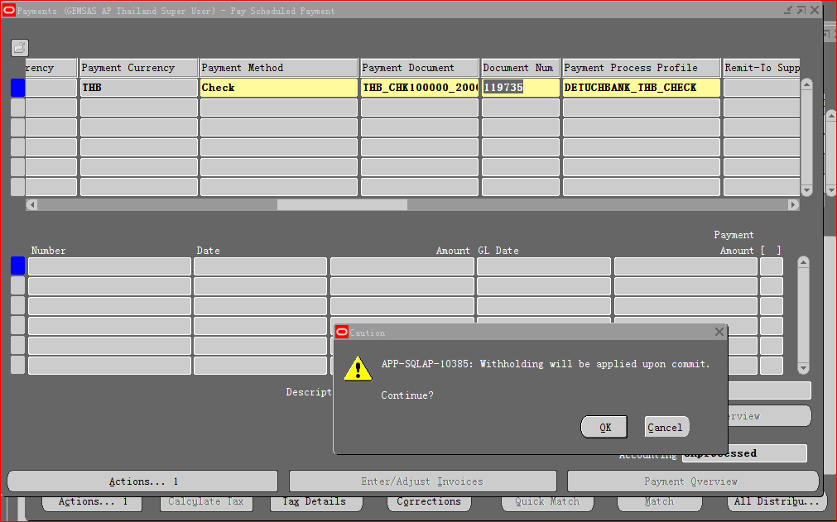

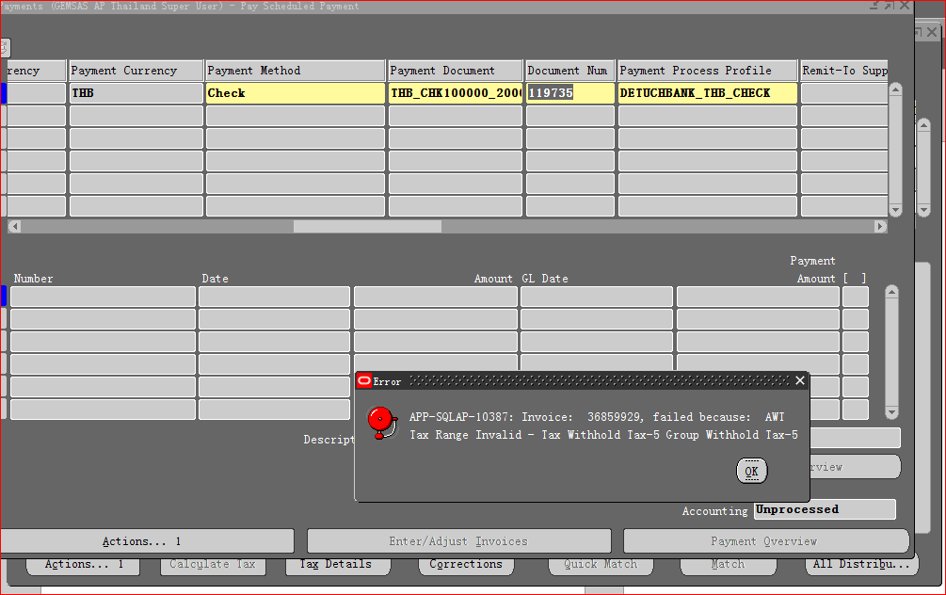

Invoice# Withholding Tax - 36859929 - 3

